A binary watch has 4 LEDs on the top which represent the **hours** (**0-11**), and the 6 LEDs on the bottom represent the **minutes** (**0-59**).

Each LED represents a zero or one, with the least significant bit on the right.

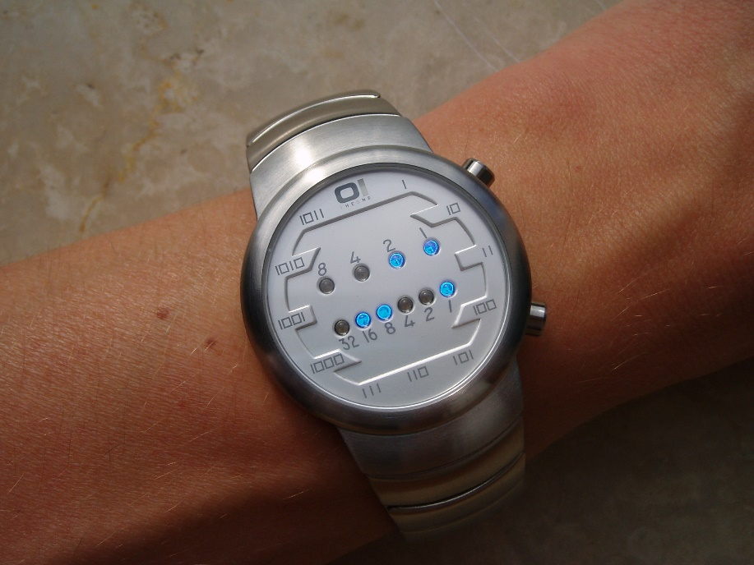

For example, the above binary watch reads "3:25".

Given a non-negative integer *n* which represents the number of LEDs that are currently on, return all possible times the watch could represent.

**Example:**

Input: n = 1  
Return: ["1:00", "2:00", "4:00", "8:00", "0:01", "0:02", "0:04", "0:08", "0:16", "0:32"]

**Note:**

* The order of output does not matter.
* The hour must not contain a leading zero, for example "01:00" is not valid, it should be "1:00".
* The minute must be consist of two digits and may contain a leading zero, for example "10:2" is not valid, it should be "10:02".